**ALIEN BANJO INVADERS**

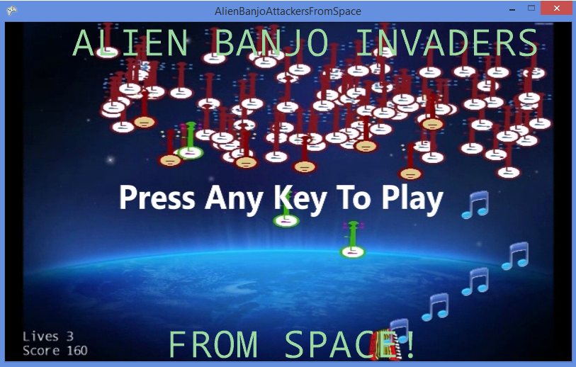

**FROM SPACE!**

**User Manual**

**CONTENTS**

PAGE 1 – INSTALLATION & RUNNING THE GAME

PAGE 2 – RULES, AIMS AND CONTROLS

**INSTALLATION & RUNNING THE GAME**

Page 1

To install the game simply download the files and run the ABAFS.exe file by double clicking it.

After you run ABAFS.exe you will be greeted with this screen:



All you need to do is press any key and you will begin the game.

**RULES, AIMS AND CONTROLS**

Page 2

The aim of the game is to survive the onslaught of banjos for as long as possible and gain the highest score you can. You earn points by killing the banjos.

|  |  |  |  |
| --- | --- | --- | --- |
| Banjo | Name | Details | Points |
| C:\Users\Armzin\Documents\Visual Studio 2013\Projects\AlienBanjoAttackersFromSpace\AlienBanjoAttackersFromSpace\AlienBanjoAttackersFromSpaceContent\PlainBanjo.png | Plain Banjo | Moves accross the screen and drops down a little at the edges.  Takes 1 shot to kill | 10 |
| C:\Users\Armzin\Documents\Visual Studio 2013\Projects\AlienBanjoAttackersFromSpace\AlienBanjoAttackersFromSpace\AlienBanjoAttackersFromSpaceContent\AttackerBanjo.png | Attacker Banjo | Moves like a plain banjo for 5 seconds then moves towards the player.  Takes 1 shot to kill | 20 |
| C:\Users\Armzin\Documents\Visual Studio 2013\Projects\AlienBanjoAttackersFromSpace\AlienBanjoAttackersFromSpace\AlienBanjoAttackersFromSpaceContent\DeadlyStrummer.png | Deadly Strummer | Moves towards the player straight away and faster than the attacker banjo.  Takes 2 shots to kill | 50 |

You control the accordion whos aim it is to save the world from the evil banjos by shooting pure accordion music notes at the banjos.

Page 3

To move the accordion use the left and right arrow keys.

To shoot the note bullets press or hold down the spacebar.

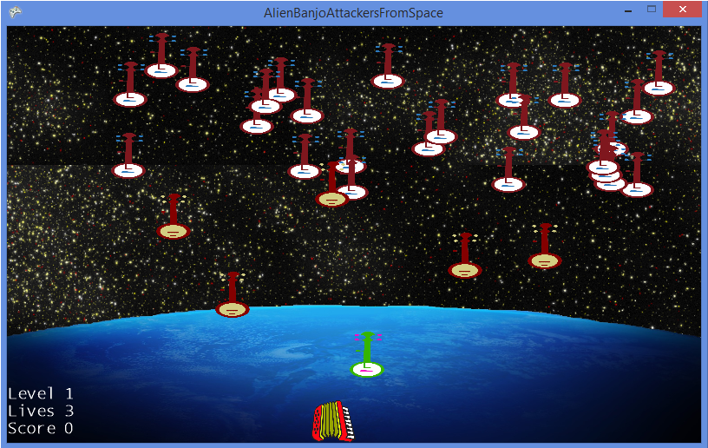You can also save the game at any point by pressing the ‘S’ button and load the game by pressing the ‘L’ button.

You have 3 lives. If a banjo flys into you then you lose a life. If you lose all 3 lives then game over. If a banjo makes it to the bottom of the screen then that is also game over. If your score beats one of the three high scores then it will replace that high score as the new high score. If you kill all the banjos on the screen then you advance a level. As you advance more banjos spawn in and the banjos move faster so be prepared!

Page 4

